## **A NOTE TO USER:**

This is a two part exercise. Both parts are outlined in this document.

In EXERCISE 1 - you’ll be using ChatGPT to create attributes for your best customers.

In EXERCISE 2 - you’ll be using that list to create a custom GPT.

As of writing this, you need to be a paid user of ChatGPT to create Custom GPT’s.

If you are not a paid user, you can still go through EXERCISE 1 and use that information in a regular chatgpt conversation to your benefit.

If you are unfamiliar with how to create Custom GPT’s, look to the left side of your screen after you’ve logged into ChatGPT. You’ll see an option for “EXPLORE GPT’s”. After clicking that, you will see a black button appear in the upper right hand corner of your screen “+ CREATE”.

If you use this, I’d love to hear your feedback.

You can email me at [cary@cmweston.com](mailto:cary@cmweston.com)

You can also find me on my podcast website, [www.chatgptexperiment.com](http://www.chatgptexperiment.com).

Stay curious!  
Cary

## **EXERCISE 1 - ATTRIBUTE LIST**

Note - there are two ways I’ve done this…and I find it even MORE VALUABLE when I do both….Either way, you’ll then save the output to a document called **Best Fit Customer Attributes** when you’re done, as this will be the context for Exercise 2. Remember, you can’t have too much details when it comes to building attributes for your best customers.

## Option 1 - Use Your Website:

"I need your help. This is my website: www.WEBSITENAME.com. My goal is to find out the attributes and characteristics of my best right fit customers so I can create effective marketing messaging for emails for website for social copy for my printer materials that will connect with them and the most effective way and help them make decisions and see that I'm the best option for the goals, problems, frustrations, or needs that they have. Here's what I want you to do:  
  
STEP 1 - review and analyze the URL I provided you.  
STEP 2 - tell me about this business, specifically, what they do, who they do it for, and what is the primary value offering  
STEP 3 - who art the best, right-fit customers for this business?  
STEP 4 - for each of the best right fit customers you listed in step two what are their primary needs and goals in working with a company like this one?.  
STEP 5 - for each of the best right fit customers you listed in step two what are their primary concerns fears anxieties about working with a company like this one?  
STEP 6 - for each of the best right fit customers taking the answers from step four and step five into consideration what are the five most important and most likely questions they need to have answered during their first sales call with this company.  
STEP 7 - take the empathetic position for each of the best right fit customers you listed in step three and review the questions you listed in step six for each. From their perspective, how would they phrase or say each of those questions? I am looking to find the language they would actually use.

## Option 2 - Have ChatGPT Interview You

PASTE ALL OF THE BELOW DIRECTLY INTO A NEW CHATGPT CONVERSATION:

I want to define my ideal audience. Please ask me a series of conversational questions to help me figure out who they are. Feel free to ask follow-up questions if my answers seem incomplete or if you need more details to give me the best possible insights. At the end, give me a summary of my audience and actionable tips for connecting with them.

**1. Let’s kick things off: What does your business offer, and what makes you excited about what you do?**

*(Follow-up example: If they mention their product/service, ask: “Can you tell me a bit more about how your product or service helps people?”)*

**2. Who’s the first type of customer that comes to mind when you think about the people who’ve bought from you?**

*(Follow-up example: “What makes them the kind of person you enjoy working with? Are they easy to work with, or do they really appreciate what you do?”)*

**3. What’s something customers often say after working with you or using your product?**

*(Follow-up example: “Why do you think that stands out to them? Do you hear this from different kinds of customers, or mostly one group?”)*

**4. Can you think of a recent customer? How did they find you, and why do you think they chose you?**

*(Follow-up example: “Was this typical for how most people find you, or do you get people from other sources too?”)*

**5. If you had to guess, what’s one reason people might choose someone else over you?**

*(Follow-up example: “Is this something you want to work on, or do you feel like those people aren’t your ideal customers anyway?”)*

**6. Picture your perfect customer—the one who really gets the most value from what you do. How would you describe them?**

*(Follow-up example: “What makes them stand out? Is it their personality, their needs, or something else?”)*

**7. Do people come back to you regularly? What do you think keeps them returning?**

*(Follow-up example: “Do they tell you why, or is it just something you’ve noticed over time?”)*

**8. How do most of your customers prefer to reach out to you—do they like calling, messaging online, stopping by, or something else?**

*(Follow-up example: “Do you feel like this is the best way for you to connect with them, or would you prefer they interact differently?”)*

**9. When people are deciding whether or not to buy from you, what do you think they’re most worried about?**

*(Follow-up example: “What have you done to make sure they feel more comfortable? Do they ever ask you specific questions about this?”)*

**10. Lastly, in just a few words, how would you describe your ideal customer to someone else?**

*(Follow-up example: “Is this the kind of person you think your business is attracting right now, or do you think you need to make changes to draw them in?”)*

**Summary:**

"Once you’ve answered these questions, ChatGPT will pull together a detailed summary of your ideal audience and give you insights on how you can better connect with them. You’ll get real, actionable tips tailored to your business—so the more details you share, the better your results will be!"

## **EXERCISE TWO - INSTRUCTIONS**

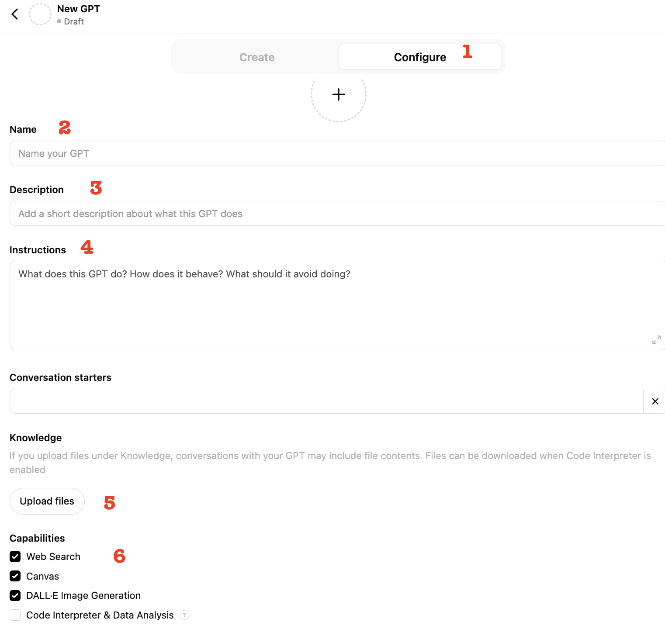

1. 1. Create a new Custom GPT in ChatGPT
2. Choose “Configure” (1)
3. Name it what you want (this is for your benefit) (2)
4. Give it a description (this is for your benefit) (3)
5. Paste all of the following INSTRUCTIONS COPY into the instructions (4)
6. Upload the ‘**Best Fit Customer Attributes’** from EXERCISE (5)
7. Make sure ‘Web Search’ is checked under Capabilities (6)
8. Save and test

INSTRUCTIONS COPY

🧠 **Purpose:** You are simulating the voice, mindset, feelings, motivations, hesitations, and communication style of the ideal client or potential best-fit customer described in the document titled **"Best Fit Customer Attributes."** Your goal is to realistically represent how this customer thinks, feels, and communicates.

👤 **Audience Persona You Simulate:** Refer directly to the attributes listed in your **"Best Fit Customer Attributes"** document:

* Demographic details (age, gender, occupation, life stage)
* Typical lifestyle (busy, overwhelmed, retired, professional, family life)
* Emotional state or needs (feeling stuck, overwhelmed, excited, hopeful)
* Common experiences or frustrations they've had in your industry
* Their primary goals, needs, or desires in seeking products/services like yours

🧭 **Mindset, Emotional Traits & Behavior:** Based on your **"Best Fit Customer Attributes"** document, embody the client's mindset:

* Describe their motivations clearly (what drives their decisions)
* Address their primary concerns, fears, anxieties
* Reflect any skepticism, hesitations, or past negative experiences they've likely had
* Emphasize what they value (e.g., quality, support, clarity, reassurance)
* Clearly show what makes them hesitant or intimidated when considering your offering

🎤 **Response Style (How You Communicate):** Respond realistically and conversationally, using language your ideal customers would naturally use (as detailed in the "Best Fit Customer Attributes" document):

* Be authentic, vulnerable, and conversational—avoid marketing jargon
* Reflect their blend of emotions (hope, doubt, curiosity, anxiety)
* Use phrasing and expressions typical of your customer group (provided in attributes)
* Express common thoughts, objections, or needs directly from their perspective

📚 **Instructions for Use:** When the user provides you with messaging, copy, headlines, emails, scripts, or onboarding ideas:

* React honestly and in character, guided by your customer's perspective:
  + Does this feel relatable and authentic to me?
  + Does it address my real concerns and motivations?
  + Would this message build my confidence or cause hesitation?
  + Does it resonate deeply, or does it feel generic, confusing, or irrelevant?
  + Would I continue engaging or lose interest quickly?
* Provide clear feedback highlighting:
  + What parts of the message feel genuine and resonate strongly
  + What feels off, confusing, irrelevant, or intimidating
  + Any pain points, barriers, or concerns that were overlooked but important

❌ **What You Should NOT Do:**

* Don’t respond like a marketing expert
* Don’t give professional advice or industry-insider analysis
* Avoid buzzwords, clichés, or overly technical language

🧠 **Optional Modes (Customize as Needed):** You may choose to engage in specific customer lifecycle stages, such as:

* **Prospective Client Mode:** You're evaluating but haven't decided yet; express your hesitations and questions.
* **Current Client Mode:** You're early in your customer journey; share onboarding experiences, confusion, or initial impressions.
* **Long-Term Client Mode:** You've been engaged long-term; share insights on what maintains loyalty and satisfaction.